Problema inverso – método adjunto – CFD – Ferlauto
FAN AND PROPELLER DESIGN VIA INVERSE PROBLEM ADJOINT EQUATIONS
- restrições geométricas (shape control) - gradiente funcinal
- Objeto = forças de volume ≠ 0, ortogonais em rel. as superfícies de fluxo)
- Lâminas vistas como superfícies deformáveis ​​e impermeáveis
- integração(no tempo) das equações que regem o escoamento
- solid mech anics (lagrangian approach)

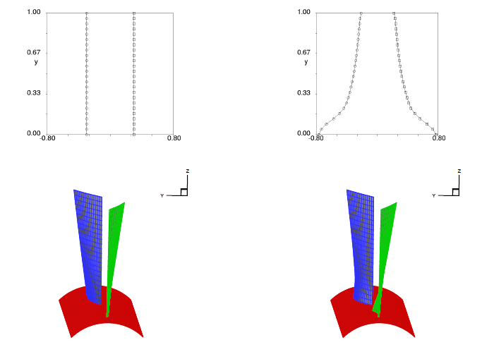
Time dependent method to solve the inverse problem for internal flows (1980)
- a
- b
INVERSE DESIGN - COOLED TURBINE BLADES - HEAT ADJOINT EQUATION
- Equação do calor material não homogêneo - Campos de geometria e temperatura
- Função Objetivo Φ - impõe restrições geométricas - Chute inicial

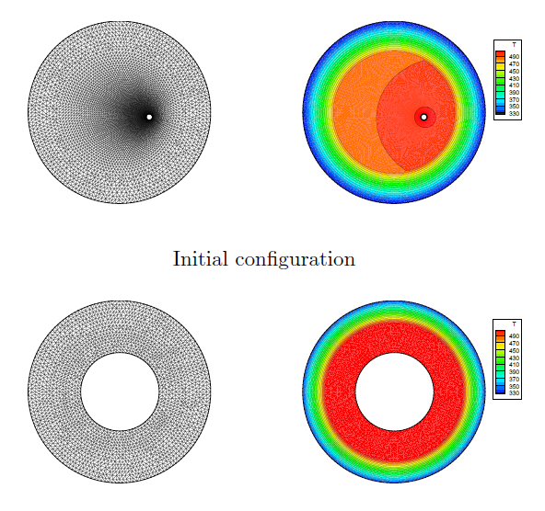

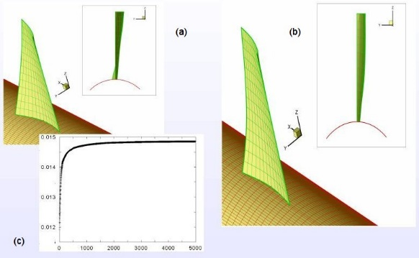 | 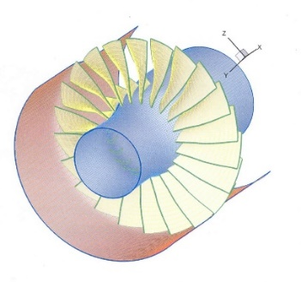
FIGURE 2: Aft-swept fan rotor. Pressure field (a) and blade geometry (b). The gray regions represent the blade projection onto the meridional plane, i.e. the blade planform. FIGURE 3: The optimization of an unducted propfan at flight Mach number M=0.6 . (a) Initial guess, (b) optimal geometry, (c) thrust versus optimization steps. FIGURE 4: Optimization of transonic fan for lowering the noise. Starting point was the NASA rotor 37.
FAN AND PROPELLER DESIGN VIA INVERSE PROBLEM ADJOINT EQUATIONS_____Ferlauto_

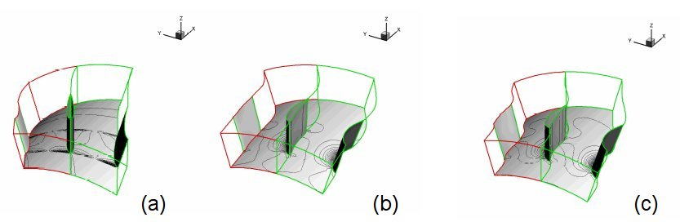 | 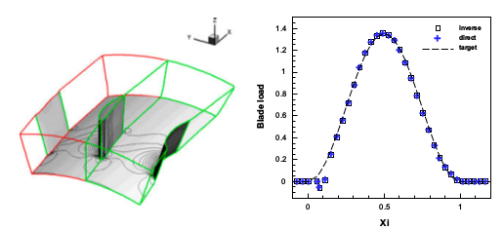
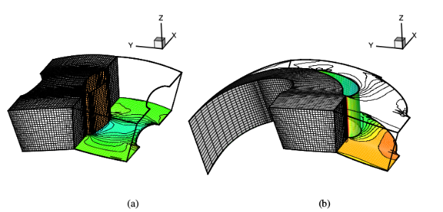 | 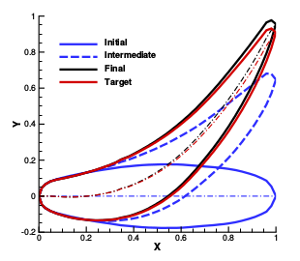
FIGURE 1: Solution of a 3-D inverse problem based on the Euler incompressible equations. A PSEUDO-COMPRESSIBILITY METHOD FOR SOLVING INVERSE PROBLEMS BASED ON THE 3D INCOMPRESSIBLE EULER EQUATIONS

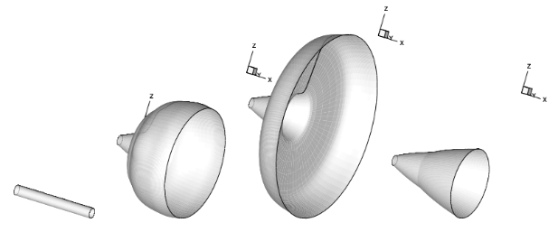 | 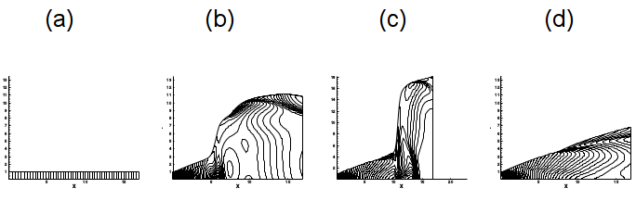
FIGURE 4: Design of a Dual bell nozzle by an Inverse Method. (a) Initial guess, (b)-(c) intermediate and (d) final geometry and pressure field
Inverse Problems for Advanced Nozzle Design_2004

